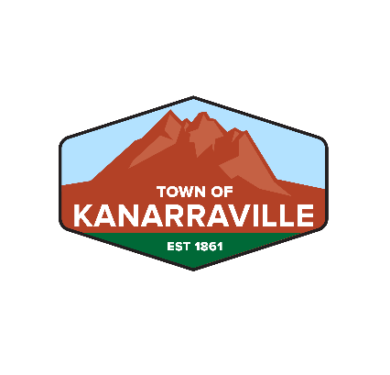

KANARRAVILLE TOWN CORPORATION

40 South Main Street, HC 65 Box 148

Kanarraville UT 84742

(435) 867-1852

WELCOME TO KANARRAVILLE!

New Resident Information Sheet

1. Fill out the Application for Water Service and return to Patti Morris, Water Department Secretary, at 40 South Main between 10 am-12 pm Mon-Fri. This application is available on the town website kanarraville.org. All water department contracts need to be filled out by the legal property owner. Water will be turned on only after payment has been received.
2. Security Deposit: Due at the time of application. The $500 Security Deposit will only be returned when the property is sold, the account has been closed and is left in good standing. Make check payable to “Kanarraville Water Department”.
3. To set-up a Post Office Box: Go to the Kanarraville Post Office with proof of property purchase between 10 am-12 pm Mon-Sat.
4. Trash cans: Each trash can is an up-front one-time rental of $95. Make check payable to “Kanarraville Water Department”. Trash cans will be delivered after payment has been received.
5. See attached Fee Schedule for all town fees relating to water, the transfer station and garbage cans and collection.
6. Kanarraville Transfer Station: Located south of town on Spring Creek Road and is a privilege reserved for residents who currently reside within the town limits and/or those who receive a monthly water bill from Kanarraville Town.

**Hours of Operation:**  
**Monday** 9 am-1 pm  
**Tuesday** 1 pm-5 pm  
**Friday** 1 pm-5 pm  
**Saturday** 9 am-1 pm

Summer the transfer station is open Saturdays from 9 am – 5 pm (May-October).

1. To hook-up electric service: Call Rocky Mountain Power at 1-888-221-7070.
2. To hook-up gas service: Call Enbridge at 1-800-323-5517.
3. To hook-up internet service: Call South Central Broadband at 1-888-826-4211 or InfoWest at 435-865-0606.